Create Postgress DB cloud

Link: https://console.neon.tech/
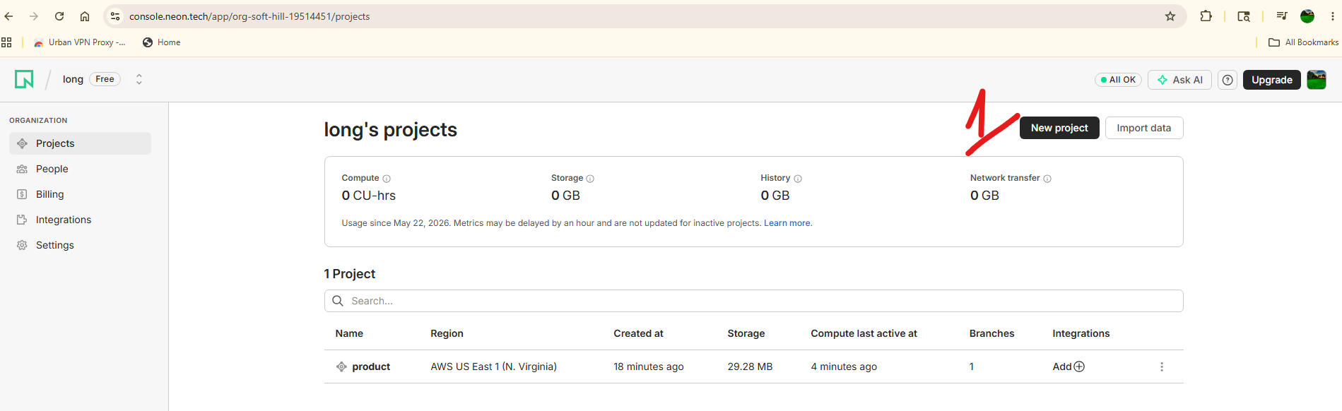

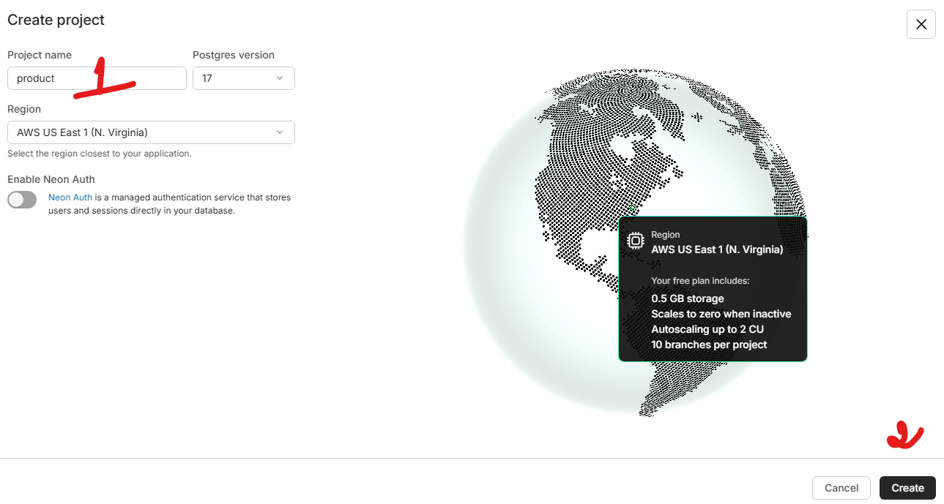

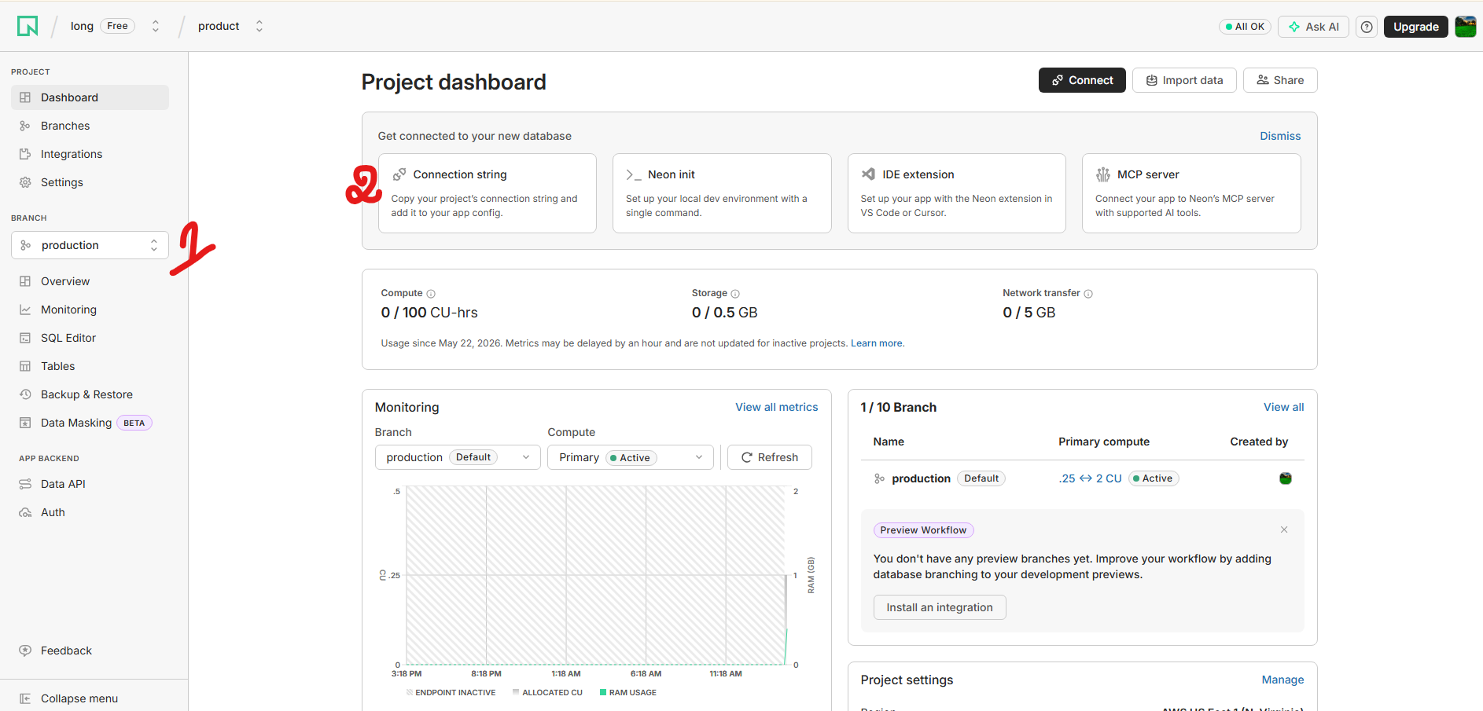

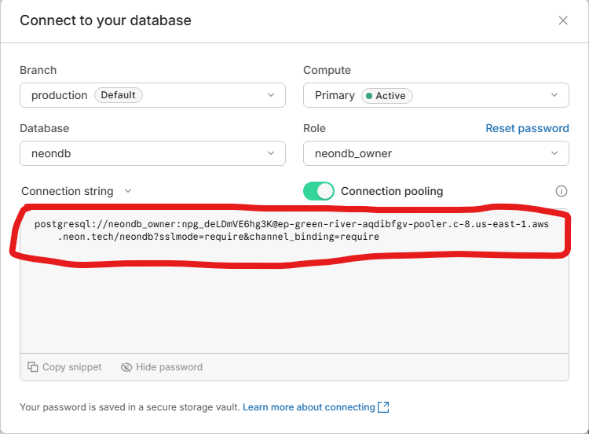

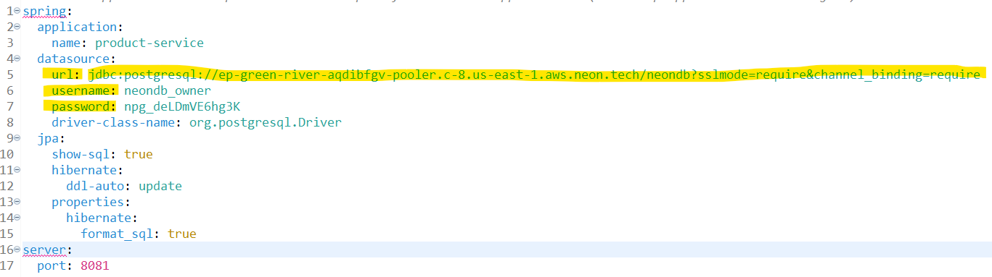

spring:
application:
name: product-service
datasource:
url: jdbc:postgresql://ep-green-river-aqdibfgv-pooler.c-8.us-east-1.aws.neon.tech/neondb?sslmode=require&channel_binding=require
username: neondb_owner
password: npg_deLDmVE6hg3K
driver-class-name: org.postgresql.Driver
jpa:
show-sql: true
hibernate:
ddl-auto: update
properties:
hibernate:
format_sql: true
server:
port: 8081

